H.T No
Regulations:
A20

Sreenidhi Institute of Science and Technology
(An Autonomous Institution)
Code No:8EC08 Date:30-12 -2024 (FN)

B.Tech IV-Year I- Semester External Examination, December-2024 (Regular and Supplementary)
ARTIFICIAL INTELLEGENCE AND DEEP LEARNING (CSE and IT)

Time: 3 Hours Max.Marks:70

Note: a) No additional answer sheets will be provided.
b) All sub-parts of a question must be answered at one place only, otherwise it will not be valued.
c) Missing data can be assumed suitably.

Bloom's Cognitive Levels of Learning (BCLL)

Remember | L1 | Apply | L3 | Evaluate | L5
Understand | L2 | Analyze | L4 | Create | L6

Part - A Max.Marks:20
Answer all QUESTIONS

 |  | BCLL | CO(s) | Marks
1 | Mention different types of agents. | L1 | CO1 | [2M]
2 | What is meant by heuristic? | L1 | CO2 | [2M]
3 | What is knowledge based agent? | L2 | CO3 | [2M]
4 | Write Bayes rule. | L2 | CO4 | [2M]
5 | What is a Convolutional Neural Network (CNN), and how does it differ from traditional neural networks? | L2 | CO5 | [2M]
6 | Define Markov Decision Process (MDP). | L1 | CO6 | [2M]
7 | What do mean by rationality? | L1 | CO1 | [2M]
8 | What is uncertainty? | L1 | CO4 | [2M]
9 | Define max pooling in CNNs. | L2 | CO5 | [2M]
10 | Mention the significance of experience replay in DQN. | L2 | CO6 | [2M]
Part – B Max.Marks:50
ANSWER ANY FIVE QUESTIONS. EACH QUESTION CARRIES 10 MARKS.

 |  |  | BCLL | CO(s) | Marks
11. | a) | Explain the properties of task environment. | L2 | CO1 | [5M]
 | b) | Can Vacuum cleaner problem be considered as AI problem? Justify your answer with suitable discussion. | L4 | CO1 | [5M]
12. | a) | Discuss in detail about A* algorithm by using a suitable example. | L3 | CO2 | [5M]
 | b) | Obtain optimal path using minimax search on the following tree/graph structure.  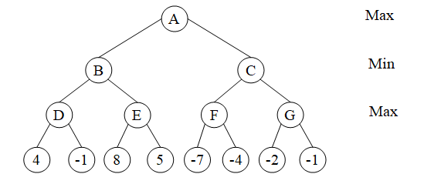 | L5 | CO2 | [5M]
13. | a) | Enumerate the steps in the process of resolution. | L2 | CO3 | [5M]
 | b) | Explain about inference in first order logic with suitable example. | L3 | CO3 | [5M]
14. | a) | Explain the following:  - Definition of POMDP.  - (ii) Decision cycle of a POMDP agent. | L2 | CO4 | [5M]
 | b) | Discuss about policy iteration algorithm for calculating an optimal policy. | L4 | CO4 | [5M]
15. | a) | Discuss the process and significance of replicating artistic styles using convolutional filters. | L2 | CO5 | [5M]
 | b) | Explain the importance of visualizing learning in convolutional networks and how it helps improve model performance. | L4 | CO5 | [5M]
16. | a) | What is the significance of the "explore versus exploit" tradeoff, and explain techniques like epsilon-greedy to handle it. | L4 | CO6 | [5M]
 | b) | Describe the architecture and working of Deep Q-Networks (DQN) and how it addresses the scalability problem in Q-Learning. | L3 | CO6 | [5M]
17. | a) | Illustrate simple reflex agent with neat diagram. | L1 | CO1 | [4M]
 | b) | Discuss about adversarial search with an example. | L3 | CO2 | [3M]
 | c) | Discuss about forward chaining. | L1 | CO3 | [3M]
18. | a) | Briefly discuss about utility function. | L2 | CO4 | [4M]
 | b) | What are the key steps involved in training a convolutional network for the CIFAR-10 dataset? | L3 | CO5 | [3M]
 | c) | Briefly explain the pole-cart problem and how policy gradients solve it. | L4 | CO6 | [3M]
-- 00 -- 00 –

